

***“PROJECT REPORT”***

***COURSE: SOFTWARE CONSTRUCTION AND DEVELOPMENT***

***Group Members:***

***Roha Ali, 2112124***

***Syeda Mahnoor Hasan, 2112135***

***Asma Hafiz Mir Nawaz, 2112106***

***Shifa Irfan, 2312175***

***Respected Teacher:***

***Ali Zaman***

***Noman Azam***

***December/2023***

|  |  |  |
| --- | --- | --- |
| **Sr.no** | **Topics** | **Page no** |
| 1 | *Summary* | 03 |
| 2 | *Purpose* | 03 |
| 3 | *Use Cases* | 03-04 |
| 4 | *Pages Explained Individually* | 04-09 |
| 5 | *Future Enhancements* | 09 |
| 6 | *Conclusion* | 09 |
|  |  |  |
|  |  |  |
|  |  |  |
|  |  |  |
|  |  |  |

***Project:***

***“Telemedicine Platform”***

***Summary:***

Telemedicine is a comprehensive telemedicine web application designed to connect patients and healthcare providers seamlessly. The platform offers a range of features to facilitate remote healthcare services, ensuring convenient access to medical care and information.

***Purpose of the telemedicine website:***

The purpose of a telemedicine website is to provide medical services remotely using telecommunications technology. Telemedicine leverages digital communication tools and platforms to enable healthcare professionals to interact with patients, diagnose medical conditions, prescribe medications, and offer medical advice without the need for in-person visits.

***Use Cases:***

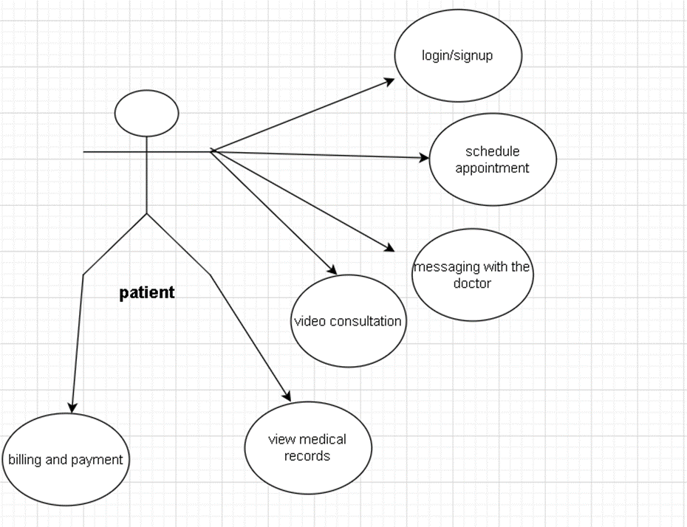

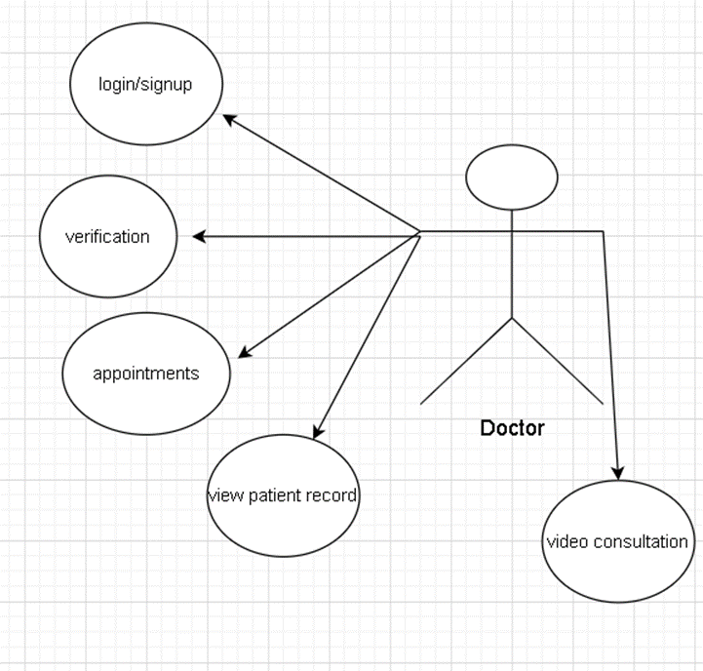

***Pages Explained Individually:***

1.PATIENT APPOINTMENT SCHEDULING:

Discuss the importance of efficient appointment scheduling.

Overview of the patient appointment scheduling system.

Features:

User registration and authentication.

User profiles with medical history.

Appointment scheduling with healthcare providers.

Confirmation notifications.

Implementation details and technologies used.

2.PATIENT MEDICAL RECORD:

The Patient Medical Report System ensures secure and efficient management of health records. With a user-friendly interface, patients can easily upload and manage medical documents, while robust security measures protect sensitive information, promoting streamlined and secure healthcare services.

Features:

User-friendly interface.

Record upload and management.

Data security.

3.PATIENT VIDEO CONSULTANT:

Highlight the significance of virtual consultations in telemedicine.

Overview of the video consultation integration.

Features:

Secure video conferencing.

Compliance with healthcare privacy regulations (e.g., HIPAA).

Technical details and integration with real-time communication solutions.

4.PATIENT PRESCRIPTION PAGE:

Discuss the importance of organized prescription management.

Overview of the prescription management system.

Features:

Viewing prescription history.

Electronic prescription issuance.

Secure storage of prescription details.

Implementation details and considerations for data privacy.

5.PATIENT MESSAGE:

Emphasize the need for secure and efficient patient-provider communication.

Overview of the messaging system.

Features:

Secure messaging between patients and healthcare providers.

Notification system for important messages.

Implementation details and considerations for security.

6. Patient Profile Page

The patient profile page serves as a comprehensive hub for patients to manage their personal information, medical history, and upcoming appointments. The key features include:

Basic Information

Display of patient's name, email, and address.

Editable form fields for easy update of personal details.

Medical History

Tabular representation of the patient's medical history.

Includes date, condition, and prescription details.

Provides a clear overview for both patients and healthcare providers.

Upcoming Appointments

Table showing upcoming appointments with details such as date, time, and attending doctor.

Helps patients keep track of their scheduled consultations.

7. Help and Support Page

The help and support page are designed to assist patients with frequently asked questions, contact information, and an inquiry form.

Frequently Asked Questions (FAQs)

Clear and concise answers to common queries regarding telemedicine.

Improves user experience by addressing concerns proactively.

Contact Information

Display of email and phone contact details for support.

Enables patients to reach out for assistance easily.

Inquiry Form

Submission form for users to submit specific inquiries.

Captures user input for further support and issue resolution.

8. Feedback and Review Page

The feedback and review page encourages patients to leave feedback and read existing reviews, fostering a transparent and trustworthy environment.

Leave Feedback

User-friendly form to submit reviews with fields for name, rating, and feedback.

Provides patients with an opportunity to share their experiences.

Display of Reviews

Existing reviews showcased in a clear format.

Helps prospective patients make informed decisions based on others' experiences.

9. Health Tracker Page

The health tracker page empowers patients to monitor and record their health-related data.

Add Health Record

Form for patients to input health records including date, weight, height, and blood pressure.

Aids in maintaining an organized and accessible health history.

Display of Health Records

Clear presentation of health records in a structured format.

Enables patients and healthcare providers to review historical health data.

10. Billing and Payment Page

The billing and payment page facilitates secure and transparent financial transactions for telemedicine services.

Invoice Details

Detailed breakdown of charges for each telemedicine consultation.

Secure and encrypted transmission of payment information.

Payment Information

Secure form for patients to input credit card details.

Integration with a trusted payment gateway for seamless transactions.

**Doctor**

Appointments Page:

Overview: The Appointments Page is a crucial component of the telemedicine website for doctors, facilitating the scheduling and management of patient appointments.

Appointment Scheduling:

Allows doctors to view, schedule, and manage upcoming appointments efficiently.

Patient Information:

Accesses relevant patient details, including medical history, to prepare for upcoming consultations.

Messages Page:

Overview: The Messages Page serves as a secure communication platform for doctors to interact with patients and collaborate with other healthcare professionals.

Secure Messaging: Enables encrypted communication between doctors and patients, ensuring the privacy and confidentiality of medical information.

Notification System: Notifies doctors of new messages and updates, ensuring timely responses to patient inquiries.

Patient Records Page:

Overview: The Patient Records Page centralizes patient health records, providing doctors with comprehensive and organized information.

Electronic Health Records (EHR): Stores and organizes patient medical histories, diagnoses, medications, and treatment plans.

Profile Page:

Overview: The Profile Page serves as the doctor's personal dashboard, allowing them to manage their account and preferences.

Personal Information: Enables doctors to update and manage their personal and professional details.

Help & Support Page:

Overview: The Help & Support Page is a resource for doctors to access assistance, guidance, and technical support.

Contact Support: Provides options to contact customer support for technical assistance or general inquiries.

Video Consultations Page:

Overview: The Video Consultations Page facilitates virtual consultations between doctors and patients, enhancing the telemedicine experience.

Video Sessions: doctor can do a video conference session with patient and discuss about their problems related to health.

Screen Sharing: Allows doctors to share screens for presentations, reviewing medical records, and explaining treatment plans.

***Future Enhancements:***

* A patient can view all the past medical records, it should be shown in the form of a graph.
* We must link an organization who is checking the doctor's license and verifying the doctor.
* There should also be a dashboard where while booking an appointment a patient can view the timings of and specialist list

***Conclusion:***

Telemedicine is a dynamic telemedicine platform designed to bridge the gap between patients and healthcare providers, offering a secure and user-friendly environment for remote healthcare services. It emphasizes convenience, accessibility, and data security to provide a holistic telehealth experience.